GoSecure Set Up Instructions

Dear Client,

Thank you for choosing Optimal Billing Solutions. We look forward to working with you. To get started I have written instructions below for you to give me permission to bill on your behalf. If you are a new graduate then the instructions to set up your GoSecure account should be on your letter from the MOH.

Once this is complete, you will need to set me up as your Designate. To do this please go to Designee Maintenance, enter my name Rebecca Walters, and my email which for GoSecure is [rebecca.walters09@gmail.com](mailto:rebecca.walters09@gmail.com).  The program will find me as a user and ask you to confirm the designee.  Once you do so, it will send me a designee confirmation email.   Once I accept it on my end, you then need to log in again, go to designee maintenance,

[GO Secure Login (gov.on.ca)](https://www.iam.security.gov.on.ca/goID/access/index.jsp?authn_try_count=0&contextType=external&username=string&contextValue=%2Foam&password=sercure_string&challenge_url=https%3A%2F%2Fwww.iam.security.gov.on.ca%3A443%2FgoID%2Faccess%2Findex.jsp&ssoCookie=Secure%3B+httponly&request_id=-6295964327004859473&OAM_REQ=&locale=en_US&resource_url=https%253A%252F%252Fwww.ebse.health.gov.on.ca%252Febs%252Findex.jsp)

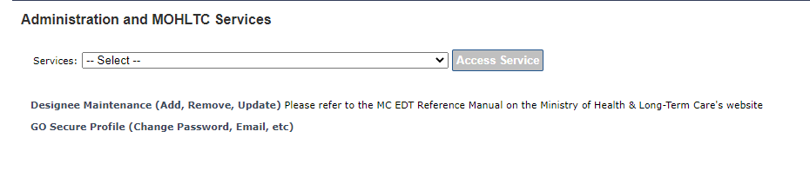

Then click on my email

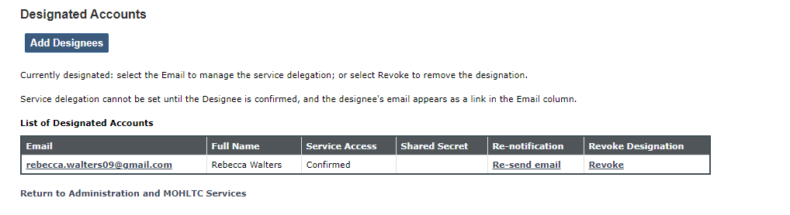

then click on MC EDT SERVICE (UPLOAD/DOWNLOAD)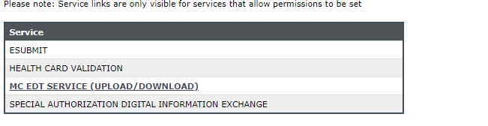

At the top of the screen click on “REMOVE ALL” then “SELECT ALL”.

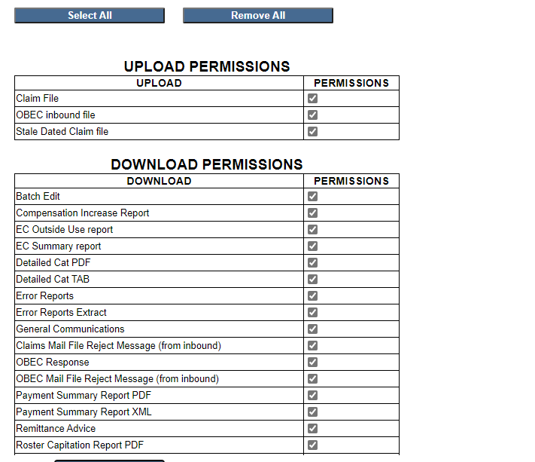

Then scroll down to the bottom of the screen and click on “SAVE”

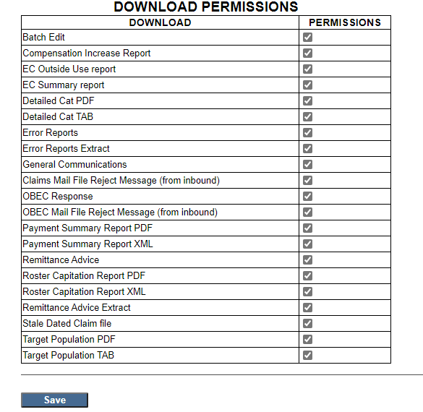

Once this is complete I have control to upload and download on your behalf. If you have any trouble with this please feel free to call me and I can walk you through it.

Regards

Rebecca Walters

Optimal Billing Solutions

905-933-2304